

ISDS 577 Capstone Project

Group 3

Table of Contents
Table of Contents 1
Executive Summary 2
Introduction 4
Data Description 5
Methodology 9
Results 29
Methodology 1 - Clustering 29
Methodology 2 - Pairwise Correlation Analysis 31
Methodology 3 - Multiple Regression 33
Methodology 4 - Various Analyses 34
Discussion 39
Recommendations for Parents 40
Limitations & Future Work 44
Conclusion 45
Reference Page 47

Executive Summary
This report examines the impact of smartphone use on teenagers, analyzing the Teen Smartphone Addiction Dataset from Kaggle to identify how smartphone behaviors predict poor academic and mental health outcomes, which behaviors contribute most to academic decline, and how these effects vary by grade level. The findings offer actionable insights for educators and parents to encourage healthier technology habits. The dataset comprises self-reported survey responses from exactly 3,000 students aged 12–18 in middle and high school, capturing 25 variables related to demographics, smartphone usage habits, time spent on activities, levels of addiction, academic performance, and mental well-being, which were transformed into 42 variables after preprocessing steps. The .CSV data file required extensive preprocessing to prepare it for machine learning analysis, including clustering, pairwise correlation analysis, multiple regression, and other statistical approaches. The results also showed that addiction levels and total smartphone usage hours were not significantly correlated with academic performance, though higher addiction scores were associated with behavioral patterns such as reduced sleep and productivity. Overall, social media-heavy use was linked to lower academic performance, higher depression, and reduced self-esteem, while gaming was associated with positive academic and emotional outcomes. Educational use supported strong academic performance but also increased anxiety, highlighting the emotional toll of academic pressures in the digital age.
While addiction levels and total screen time do not directly correlate with poor grades, higher phone use is linked to behaviors like reduced sleep and productivity, which can have indirect negative effects. Parents can encourage healthier habits by setting limits on screen time during school nights, establishing tech-free zones (e.g., no devices before bedtime), and supporting offline activities like sports, hobbies, or family time, which promote confidence, stress relief, and relationship-building.
This project offers valuable insights into teenage smartphone use; however, several limitations must be acknowledged. The data is self-reported, which introduces risks of inaccurate responses due to overestimation, underestimation, or social desirability bias. Additionally, the dataset represents a single geographic and cultural context, limiting its generalizability to other regions or socioeconomic groups. The analyses are correlational, not causal, meaning that observed relationships (e.g., between social media use and lower academic performance) cannot definitively establish cause and effect, as unmeasured factors such as sleep quality, parenting styles, or mental health history could influence the results.

Introduction
In today's digitally-driven world, it is not uncommon for close friends to gather, yet they find themselves worlds apart, absorbed by the screens in their hands. Instead of an animated conversation at a casual establishment of their choice, the table between them is dominated by the soft glow of their smartphones. They’re scrolling through an endless stream of social media updates, finding their mood dipping as they subconsciously compare themselves to the seemingly perfect lives of others. Across the cafe, Someone else juggles work emails and messages, a digital tether that amplifies stress and makes true relaxation elusive.
This scene, all too familiar, highlights a growing concern: if these devices can overwhelm and distract full-grown adults with decades of life experience before they've even had a chance to use smartphones, what on Earth are these devices doing to future generations? This report places smartphones “in the hot seat” to examine their influence on teenage life. Using the Teen Smartphone Addiction Dataset from Kaggle, this analysis explores three dimensions of concern: (1) what profiles of smartphone use predict poor academic or mental health outcomes, (2) which combinations of behaviors most strongly predict academic decline, and (3) how these relationships differ across grade levels. The results provide data-driven insights for educators and parents seeking actionable ways to promote healthy technology habits.

Data Description
Below are two summary tables. The first one lists the different variable types and provides a description of each. Next, you can see the different variables from the dataset. It includes a basic description of the variable, along with its type.
Table 1. Variable Types
Variable Type | Description
Integer | A whole number (e.g., 1, 2, 3, 4,...)
Float | A number that includes a decimal (e.g., 3.14, 5.56, 7.62)
String | A line of characters
Categorical | From a category (e.g., Woman, Man, Child)
Ordinal Integer | A whole number, but it implies a ranking system of some sort

Table 2. Variable Names
Variable Name | Description | Type
ID | Unique identifier for each participant | Integer
Name | Participant’s name (will be dropped for privacy) | String
Age | Age in years | Integer
Gender | Gender | Categorical
Location | City/Town of residence (will be dropped for privacy) | String
School_Grade | Current Grade in school | Ordinal Integer
Daily_Usage_Hours | Average daily phone usage (hours) | Float
Sleep_Hours | Average daily sleep duration (hours) | Float
Academic_Performance | % Grade out of 100 | Interger
Social_Interactions | Frequency/quality of in-person social interactions | Ordinal Integer
Exercise_Hours | Weekly exercise duration (hours) | Float
Anxiety_Levels | Self-reported anxiety (0-10 scale) | Ordinal Integer
Depression_Level | Self-reported depression (0-10 scale) | Ordinal Integer
Self_Esteem | Self-esteem score(0-10 scale) | Ordinal Integer
Parental_Control | Level of parental monitoring | Ordinal Integer
Screen_Time_Before_Bed | Phone use before bed (hours) | Float
Phone_Checks_Per_Day | Number of times the phone is checked daily | Integer
Apps_Used_Daily | Number of distinct apps used daily | Integer
Time_on_Social_Media | Daily time spent on social media (hours) | Float
Time_on_Gaming | Daily gaming time (hours) | Float
Time_on_Education | Daily time on educational apps (hours) | Float
Phone_Usage_Purpose | The primary purpose of phone use | Categorical
Family_Communication | Frequency of family communication via phone | Ordinal Integer
Weekend_Usage_Hours | Average daily phone use on weekends (hours) | Float
Addiction_Level | Smartphone addiction index (0-10) | Float/Ordinal Integer

The dataset, hosted on Kaggle, contains self-reported survey responses from 3,000 students aged 12–18 across middle and high schools. It captured 25 variables, including demographics, smartphone habits, time spent by activity type, and self-assessments of addiction, academic performance, and mental well-being.
This topic resonated deeply with us, as it is extremely relevant to our daily lives, and the full extent of these phenomena is far from being fully understood. To maintain privacy and adhere to ethical guidelines, we will exclude the “Name” and “Location” columns, ensuring no legal or privacy concerns arise with our dataset usage. The data from Kaggle was provided in a CSV file, and there is no need to integrate additional datasets for our project. The original dataset requires numerous preprocessing steps, as it consists of raw data in various variable types that machine learning models cannot understand. To assist with the data cleaning, we used Python and Google Colab. Categorical data is not always the best for data analysis. Originally, the data listed (x) participants as “Female, 12th grade”. Hence, we plan to convert categorical variables into dummy variables and conduct feature engineering on attributes such as Gender and School_Grade. (A dummy variable is a variable in which there are only two possible values.) This preprocessing will result in a final dataset comprising approximately 3,000 records across 42 columns. There were 0 missing values in the dataset, which is great; it eliminates the need for further data cleaning. Figure 1 illustrates the preprocessed step of converting categorical variables into dummy variables.
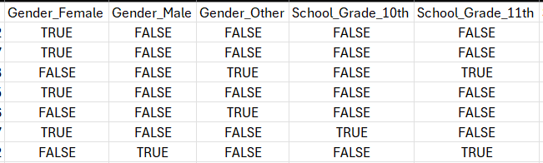
Figure 1. Example of the dataset after preprocessing, where categorical variables (e.g., Gender, School_Grade) have been converted into dummy variables. This transformation enables categorical features to be used in statistical and machine learning models that require numeric inputs.

For now, let us proceed to the methodology section of data analysis.

Methodology
We employed three primary methodologies: clustering, pairwise interaction analysis, and quantitative correlation analysis, as well as various other methods, to correct for oversights between the three primary methods. We conducted all the analysis in Google Colab, which utilizes Python code as its input mechanism and is also capable of leveraging various packages to generate visual representations of the data, as you will see shortly.
According to IBM, “Clustering is an unsupervised machine learning algorithm that organizes and classifies different objects, data points, or observations into groups or clusters based on similarities or patterns.” IBM (N.D.). For the clustering analysis, Clara included a combination of behavioral and contextual variables to capture the multifaceted nature of smartphone use. These variables included daily and weekend usage, primary activity type (gaming, social media, education, or other), frequency of phone checks, parental control measures, and sleep duration. Using these measures, Clara split the 3,000 observations into four major clusters, each representing a distinct profile of teen smartphone users:
  - Cluster 0: Gaming-focused teens
    - Usage Profile:
      - High daily (≈5.1 hrs) and weekend use (≈6.0 hrs)
      - Primary purpose: Gaming
      - Moderate social media use and average parental control
  - Cluster 1: High social media use
    - Usage Profile:
      - Slightly lower daily usage (≈4.9 hrs)
      - Primary purpose: Social media
      - High frequency of phone checks (≈84/day), moderate parental control
  - Cluster 2: Education-focused phone usage
    - Usage Profile
      - Moderate daily usage (≈4.9 hrs) and higher sleep hours (≈6.6 hrs)
      - Primary purpose: Education (only cluster with education =
      - Balanced time across apps, moderate parental control
  - Cluster 3: Mixed group
    - Usage Profile
      - Similar total usage to others (≈5.1 hrs/day)
      - Mixed purposes: ~50% “other” activities (streaming, browsing, etc.) Moderate use across all categories
Please refer to Figures 2-6 to view the box plots and a table that displays the median values in a color-coded format, highlighting the best and worst performers. We will dive deeper into the analysis in the next section.

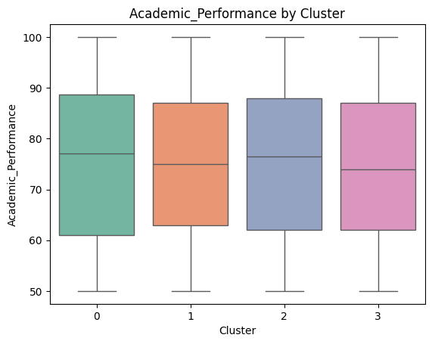
Figure 2. Box plot showing the academic performance of Clara’s 4 clusters. We see that Cluster 0, the gaming-focused teens, has the highest median academic performance, followed closely by Cluster 2, the Education-focused phone usage group

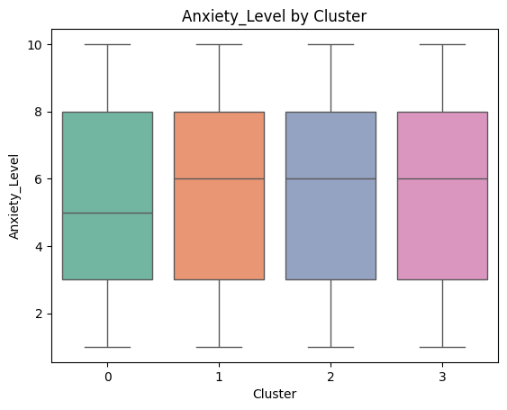
Figure 3. Box plot showing the anxiety levels of Clara’s 4 clusters. We see that Cluster 0, the Gaming-focused teens, have the lowest median anxiety level.

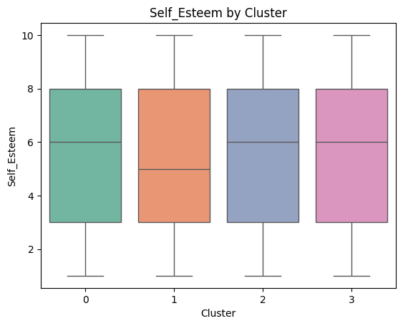
Figure 4. Box plot showing the self-esteem levels of Clara’s 4 clusters. We observe that Cluster 1, characterized by high social media use, has the lowest median self-esteem.

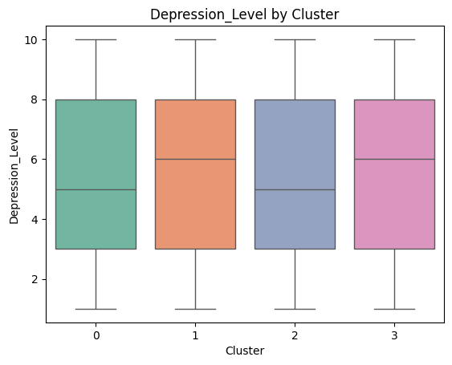
Figure 5. Box plot showing the depression level of Clara’s 4 clusters. We observe that Clusters 0 and 2 have the lowest median depression levels.
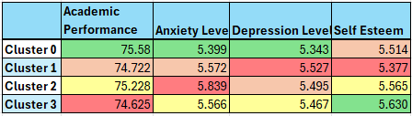
Figure 6. A table showing all median values of each box plot across the 4 different categories. The color coding from best to worst goes - Green, Yellow, Orange, Red

The next methodology was overseen by researcher Eric. He conducted a pairwise correlation analysis on the dataset, highlighting the addiction level and academic performance. According to Fantom, “Correlation analysis is a statistical technique used by data analysts to explore and understand the relationships between different variables…measuring the strength of that connection, and determining its direction.”(2023). Eric performed a battery of tests on the dataset inside Google Colab, including the below:
- One-Way ANOVA for Academic_Performance vs Addiction_Level
  - ANOVA is an abbreviation for analysis of variance
  - Assumes data is normally distributed (bell-curved)
- Kruskal-Wallis H-test
  - “Essentially, this test determines if the groups have the same median.” Lomuscio (2021).
  - It is used when data is not normally distributed
- Dunn-Bonferroni post-hoc test
  - According to EasyMedStat, “...a statistical procedure used to compare multiple pairs of means (averages) in a group of data. It is often used after conducting a statistical test that compares means, such as an analysis of variance (ANOVA).” (2022).
- Pearson correlation coefficient
  - “... measures the strength and direction of the linear relationship between two variables. It quantifies the extent to which the data points of the variables tend to cluster around a straight line.” Fantom (2023).
Unfortunately, this section will become somewhat technical; however, please note that all tests were coded and run in Google Colab. For the One-Way ANOVA, we started with a null hypothesis and an alternative hypothesis. (A hypothesis is an educated guess that needs to be proved or disproved via a test.) We aim to reject the null hypothesis and support the alternative one. In our case, the null hypothesis is that the average academic performance is the same across all addiction categories, while the alternative hypothesis is that at least one addiction category has a different average academic performance. Once we ran the test, it yielded a p-value of 0.4934, which we will use in the next section to determine whether to reject or not reject the null hypothesis. The Kruskal-Wallis H-test is very similar to the ANOVA test and was performed in much the same way. It also gave us a p-value of 0.4934. This test was also performed just in case the dataset is not normally distributed.
Eric then ran a Dunn’s Post-Hoc Test, which is used in conjunction with the Kruskal-Wallis H-test. As long as the Kruskal-Wallis test gives us a significant p-value, Dunn’s test will identify which specific pairs of addiction category groups have significantly different median academic performance. Lastly, he determined the Pearson correlation coefficient. This coefficient is used to determine the strength and direction (positive or negative) of the relationship between the addiction level and the variable. Please see Figure 7 below for a heatmap showing the correlations:
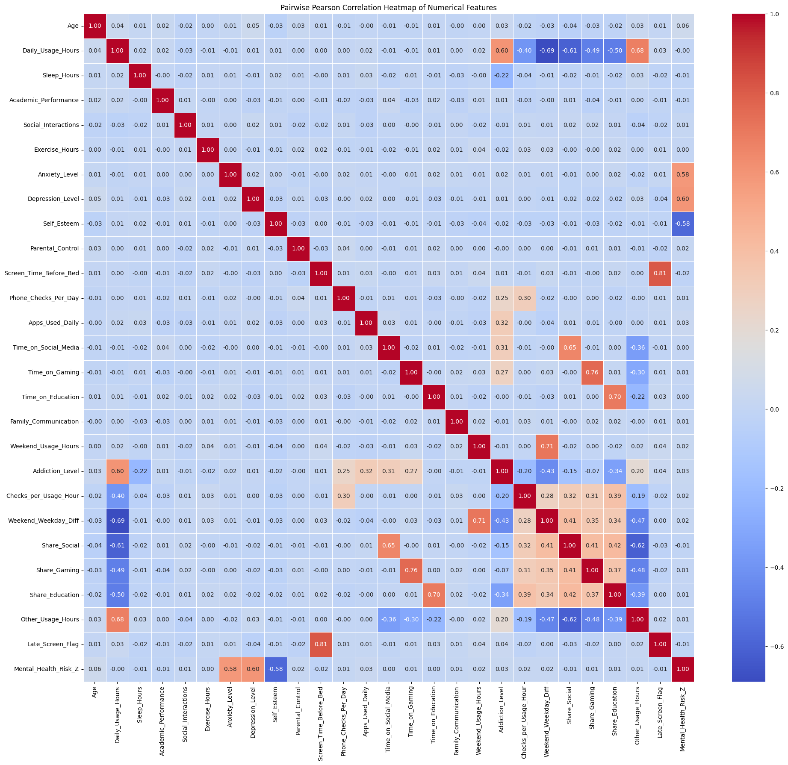
Figure 7. Heatmap correlation analysis using Pearson’s coefficient measures the relationship between variables.
Researcher Keerthana is next up; she ensured her model was tested to determine if academic performance and mental health were consistent across grade levels. She modeled two dependent variables. Academic Performance (score 0–100) and Mental Health Risk, a reversed composite index where higher scores represent worse mental health. Predictors, or independent variables, included:
- Apps_Used_Daily
- Screen_Time_Before_Bed
- Apps_Used_Daily
- Phone_Checks_Per_Day
- Time_on_Social_Media
- Time_on_Gaming
- Time_on_Education
- Weekend_Usage_Hours
- Addiction_Level
Grade-level interactions identified shifts in usage effects across developmental stages and the adjusted least-squares means. Figures 8 and 9 summarize baseline differences before modeling. Academic scores remain relatively stable across grades, whereas mental-health risk slightly increases in 11th grade.

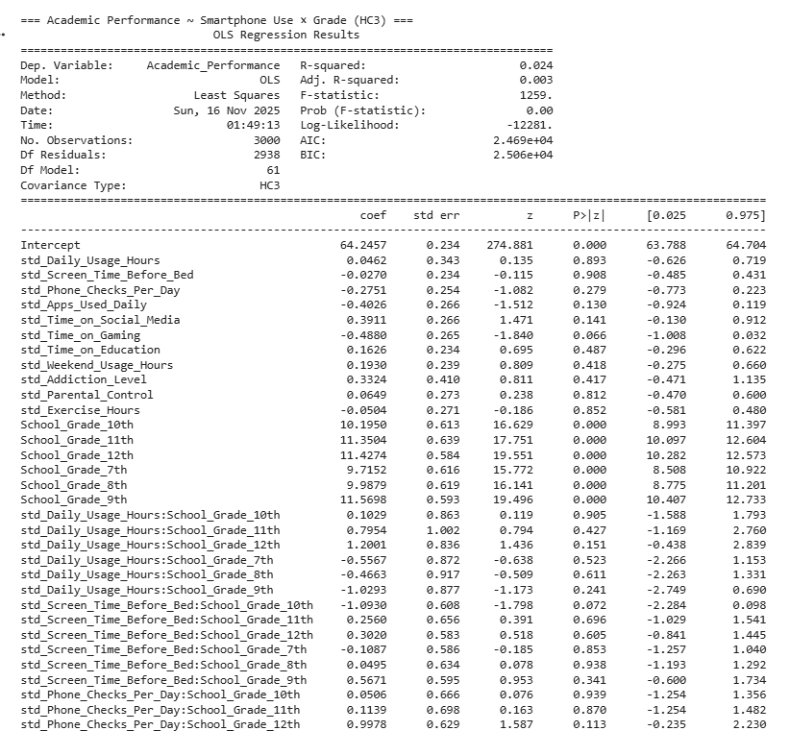
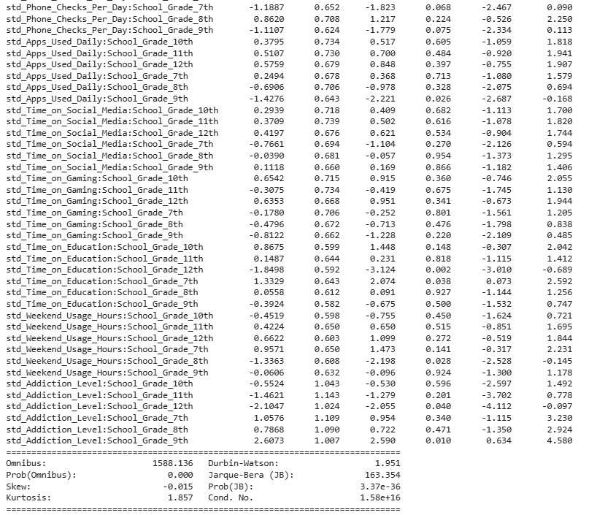
Figure 8. Adjusted Academic Performance by Grade
Note for Parents: The statistical table in Figure 8 details the raw data from our analysis. The key takeaway is that total smartphone usage time does not strictly predict poor grades. Instead, our findings show that academic performance depends more on the student's specific grade level and the purpose of their usage (e.g., using educational apps vs. passive scrolling) rather than just the number of hours logged.

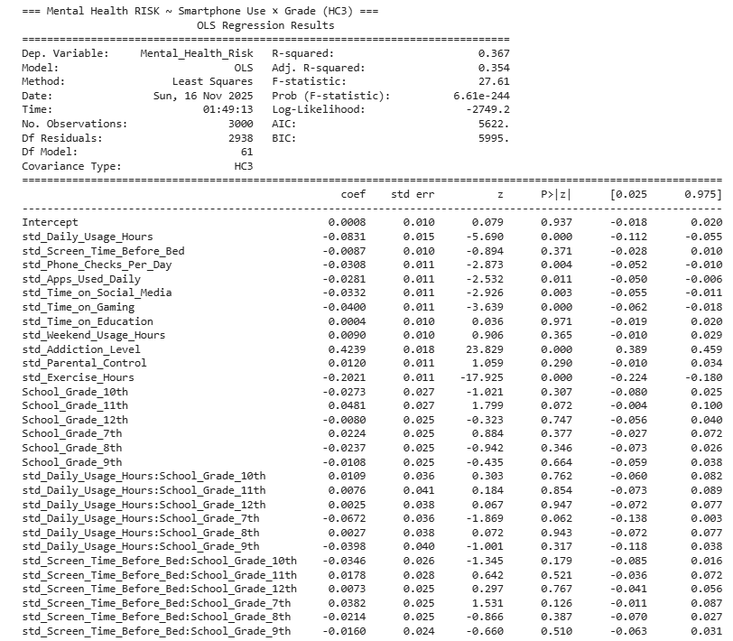
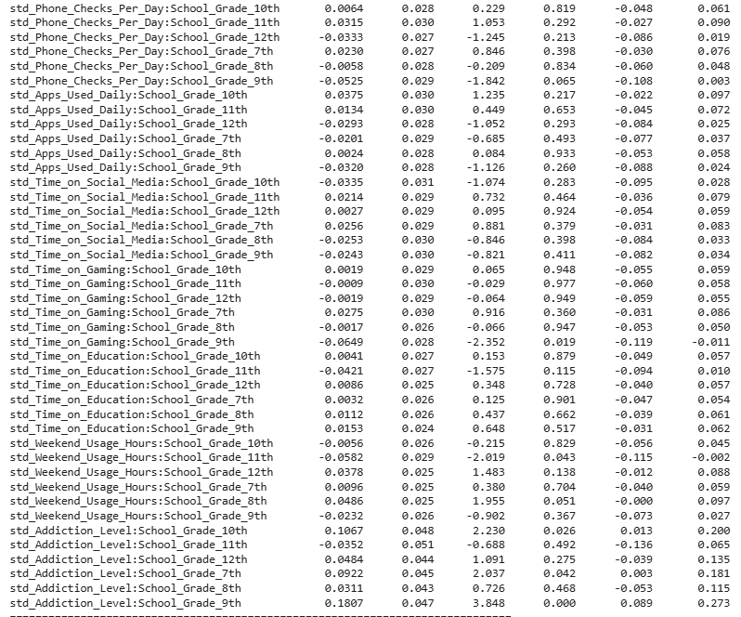

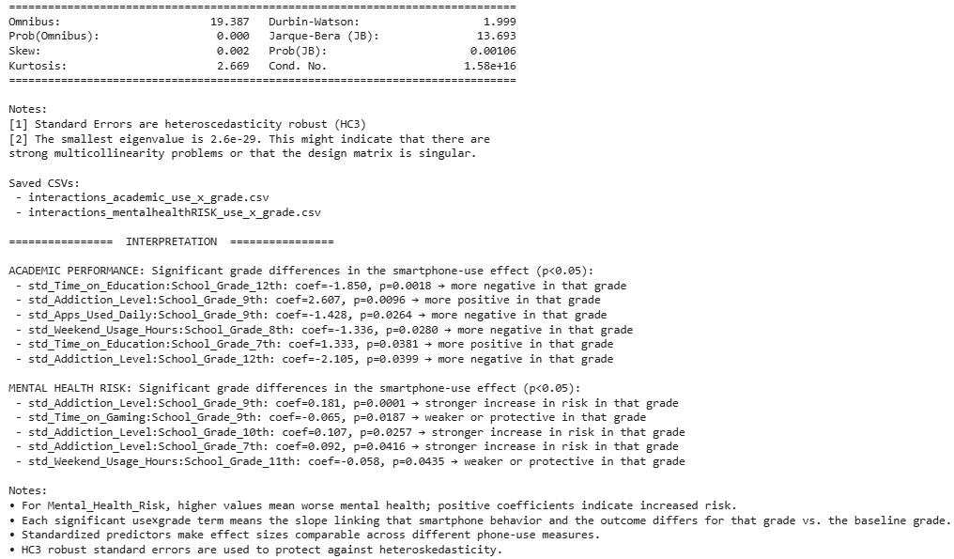
Figure 9. Adjusted Mental Health Risk by Grade
Note for Parents: The table in Figure 9 displays the statistical factors influencing mental health risks in our dataset. The data confirms that "Addiction Level", defined as compulsive checking and emotional dependence on the device, is a much stronger predictor of mental health struggles than the simple amount of time spent on a screen. Routine usage is less concerning than addictive behavior.

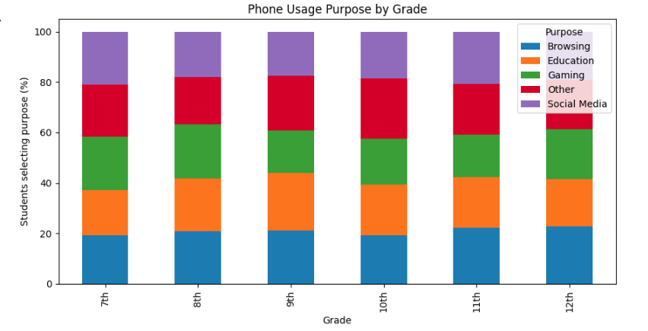
Figure 10. Phone Usage Purpose by Grade & proportion of students reporting primary use for education, gaming, social media, or browsing.

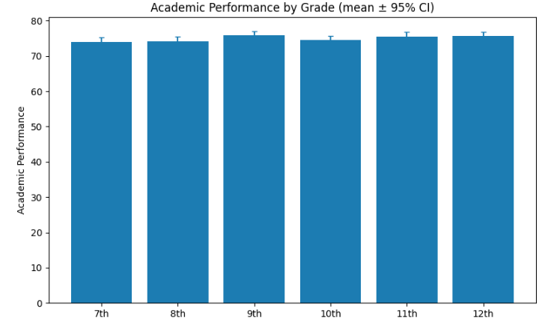
Figure 11. Academic Performance by Grade (95 % CI). Average scores across grades 7–12.

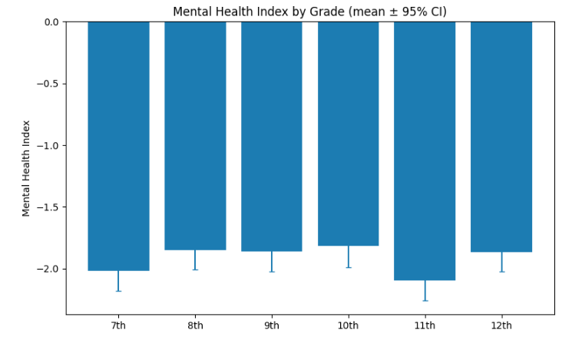
Figure 12. Mental Health Risk by Grade (95 % CI). Average risk index: 11th grade shows a slight peak.
Lastly, researcher Angel conducted two additional analyses to determine whether distinct smartphone usage profiles were predictive of academic or mental health outcomes. To achieve this, she first conducted two regression models using academic performance and depression level as the dependent variables.
To determine whether meaningful usage patterns existed at a group level, we conducted a K-means clustering analysis. K-means clustering is “an algorithm that categorizes data points using the mathematical distance between that point of data and the cluster center with the goal of minimizing the sum of distances between data points and their assigned clusters” Kavlakoglu and Winland (N.D.). In order to optimize the number of clusters, Angel used the elbow method. This method starts with calculating the “within cluster sum of squares” (WCSS) and then plotting WCSS vs number of clusters on a (X, Y) coordinate plane. Unlike the previous clustering method, Angel’s analysis examined which usage profiles were most predictive of negative outcomes, whereas Clara focused on identifying patterns of smartphone usage and their differences in academic performance and mental health. The elbow plot, as shown in Figure 15, confirmed that three clusters best represented the underlying behavioral structure.
Lastly, we used a heatmap to summarize the cluster-level averages as shown in Figure 16. The heat map showed us three distinct profiles:
- Profile 0 (Light/Moderate Users), characterized by moderate social media and gaming, with slightly lower daily usage
- Profile 1 (Heavy Users), who reported the highest overall and nighttime screen time
- Profile 2 (Educational/Balanced Users), who showed the highest engagement with educational apps.
All four researchers did their best with the dataset, and a closer examination reveals the final results. Across different usage profiles, clusters, and categories.

Results
We have divided the “Results” section of the report into sections, with the methodology being the dividing factor. This will allow readers to follow along more easily with the results than if we had started from the beginning to the end. It also allows readers to follow up on their preferred methodology without having to read the entire section.

Methodology 1 - Clustering
The first cluster, the Gaming-Oriented Users, consisted of teens who reported high daily and weekend smartphone use, with gaming as their primary activity. Although this group spent the most time gaming, they also tended to have higher average academic performance scores compared with other clusters. They reported relatively lower levels of anxiety and depression. These patterns suggest that, for these teens, gaming may function primarily as a recreational activity rather than a source of stress or avoidance. In this sample, heavy gaming was not associated with poorer well-being.
In contrast, the Social Media-Focused Users in Cluster 1 showed a different profile. While their total daily usage was slightly lower than that of the gaming group, their frequent phone checking and focus on social media were associated with lower academic performance. This cluster also reported higher levels of depression and lower self-esteem, consistent with concerns about social comparison, cyber pressure, and compulsive scrolling behaviors. These findings indicate that the nature of social media engagement may be more closely linked to negative outcomes than total hours of screen time.
Cluster 2 represented Academically-Oriented Users, characterized by moderate overall phone usage and the highest average sleep duration. Their smartphone use was primarily focused on educational purposes, and they tended to perform well academically, with scores comparable to the high-performing gaming group. However, they also reported the highest levels of anxiety, suggesting that academic-related phone use may coincide with emotional strain. Even though their academic outcomes were strong, their elevated anxiety appears associated with academic phone use, highlighting a potential emotional trade-off.
The final cluster, Mixed/General Users, showed balanced patterns across multiple activities, including streaming, browsing, and other general-purpose functions. Their total usage was similar to most other groups, without a strong emphasis on any single activity type. This balanced pattern corresponded with stable academic performance and average anxiety and depression levels. Notably, this group reported the highest self-esteem scores, which may indicate that flexible and diversified smartphone use is linked to healthier emotional regulation and lower pressure to engage compulsively with a single app type.
Overall, these findings suggest that patterns of smartphone use are more closely linked to teen outcomes than total usage time alone. Gaming was not associated with negative academic or emotional outcomes in this sample, whereas heavy social media engagement, particularly frequent checking, was linked to lower academic performance and poorer mental health. Educational smartphone use was related to strong academic performance but also higher anxiety. Mixed-use patterns were generally associated with higher self-esteem and balanced well-being.

Methodology 2 - Pairwise Correlation Analysis
To streamline the analysis, the Addiction_Level column of the dataset was categorized into three groups: Low Addiction (0-3.5), Medium Addiction(3.6-6.5), and High Addiction (6.6-10). Statistical tests were conducted to determine the relationship between these categories and Academic_Performance. The one-way ANOVA test (F-statistic: 0.7066, p-value: 0.4934) revealed no significant differences in mean Academic Performance across the addiction categories. In order for the result to be significant, the p-value would need to be lower than .05, and the F-statistic would need to be 3.00 or higher. This finding was further confirmed by the non-parametric Kruskal-Wallis H-test and Dunn's post-hoc test with Bonferroni correction. This reinforces the conclusion that addiction levels do not significantly impact academic performance.
The Pearson correlation analysis between Addiction_Level and other numerical features revealed several significant relationships. The key to remember in these relationships is that they are direct relationships. They can be positive or negative, any value between zero and one. Since they are direct relationships, a positive correlation will increase Addiction_Level, and conversely, a negative correlation will decrease it. One last thing, a value closer to one signifies a stronger correlation, while a smaller value denotes a weaker correlation. Positive correlations were observed between Addiction_Level and the following variables:
- Daily_Usage_Hours (0.6008)
- Apps_Used_Daily (0.3193)
- Time_on_Social_Media (0.3066)
- Time_on_Gaming (0.2731)
- Phone_Checks_Per_Day (0.2463)
Negative correlations were found with
- Weekend_Weekday_Diff (-0.4321)
- Share_Education (-0.3410)
- Sleep_Hours (-0.2167)
These patterns suggest that increased phone usage, as well as reduced sleep and education-related activities, are associated with higher addiction levels. However, variables such as Academic_Performance, Anxiety_Level, and Depression_Level showed near-zero correlations with Addiction_Level, indicating no meaningful linear relationship.
In conclusion, while phone addiction is strongly linked to behavioral patterns such as increased phone usage and reduced productivity (e.g., decreased sleep and educational time), it does not appear to have a significant direct impact on academic performance. These findings align with the statistical tests conducted, which consistently showed no significant differences in academic performance across different levels of addiction.

Methodology 3 - Multiple Regression
The academic model explained minimal variance (R² = .024), showing that smartphone time alone does not predict grades. However, grade-specific patterns appear:
- Early-grade benefit: Seventh-grade students who spend moderate time on educational apps achieve higher scores, suggesting that constructive academic use is more effective when parental structure is high.
- Senior-year fatigue: Twelfth-grade students who used educational apps heavily or had higher addiction scores performed slightly worse, possibly reflecting digital overload and academic burnout.
- Transition pressures: Eighth- and ninth-grade students who used many apps or logged long weekend hours displayed modest grade dips, indicating difficulty balancing leisure and coursework during early adolescence.
These nuanced differences support prior research, which shows that device impact depends on context and maturity (Amez & Baert, 2020). For educators, this pattern highlights that guidance, rather than restriction, fosters positive outcomes.
The mental-health model explained 36.7 percent of variance (R² = .367), revealing stronger and more consistent behavioral effects. Addiction Level emerged as the dominant predictor: higher addiction scores related to higher mental-health risk (β = 0.42, p < .001). The association was strongest in grades 7, 9, and 10, matching literature that links early addictive use to anxiety and poor sleep (Sahu et al., 2019; Arooj et al., 2025).
By contrast, gaming and total hours showed small negative coefficients, implying that structured leisure may relieve stress when not excessive. Exercise predicted lower risk, reaffirming protective lifestyle factors. The overall pattern suggests that the harm originates from compulsive engagement, rather than general screen exposure (Domoff et al., 2020).

Methodology 4 - Various Analyses
Based on the regression results shown in Figure 13, none of the smartphone-related predictors, including time spent on social media, gaming, educational apps, daily usage hours, phone checks, or screen time before bed, showed a statistically significant relationship with academic performance. The coefficients were small, inconsistent in direction, and lacked practical significance, resulting in extremely poor explanatory power (R² = –0.007, RMSE = 15.060). A negative R² indicates the model performs worse than simply predicting the mean, suggesting that academic performance in this dataset is largely unrelated to smartphone behavior.
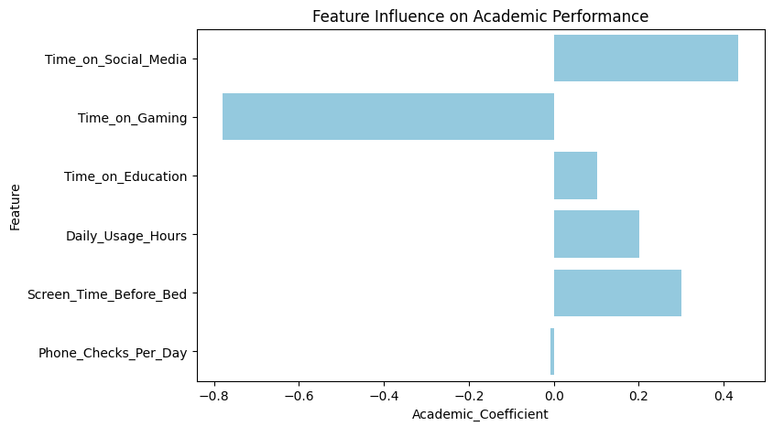
Figure 13. Regression coefficients for academic performance across smartphone activities.
A similar pattern emerged in the depression model shown in Figure 14. Although social media and gaming displayed small positive coefficients, and educational use and screen time before bed displayed small negative coefficients, none of these effects were substantial or statistically meaningful. The model explained almost none of the variance in depression levels (R² = –0.006, RMSE = 2.838), reinforcing that smartphone behaviors are not reliable predictors of mental-health outcomes.
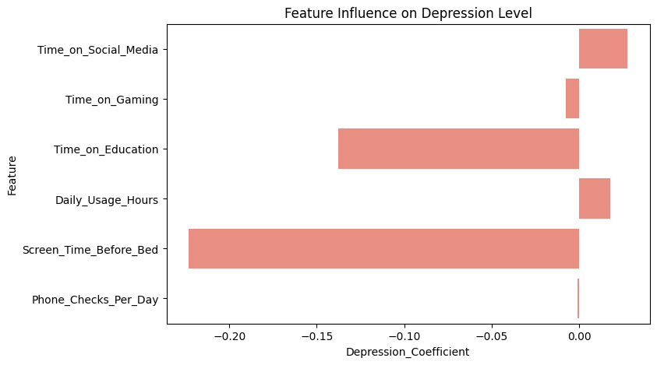
Figure 14. Regression coefficients for depression across smartphone activities.

The optimal number of clusters was determined using the elbow method, as shown in Figure 15, which indicated that three clusters best represented the underlying behavioral structure. After fitting the K-means model with k = 3, the heatmap in Figure 16 revealed three distinct usage profiles: light/moderate users, heavy users, and educational/balanced users. Despite clear behavioral differences across these profiles, academic performance, anxiety, and depression levels remained nearly identical across groups.
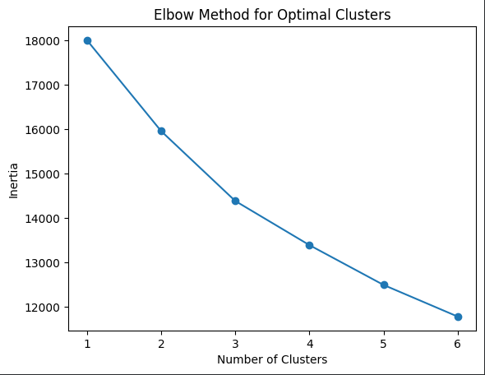
Figure 15. Elbow plot shows that k = 3 provides the most interpretable clustering structure.
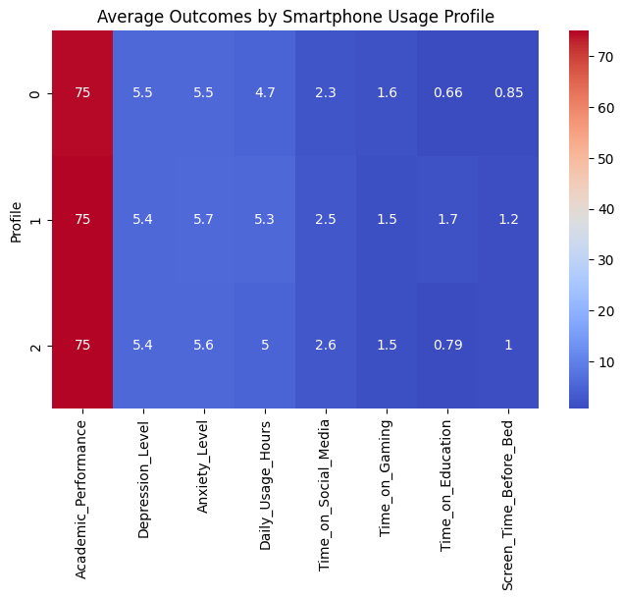
Figure 16. Heatmap showing average outcomes for each smartphone usage profile.
Overall, these findings align with Eric’s interaction analysis, which also found that total smartphone use and addiction level were not strongly associated with academic performance. The overall pattern suggests that smartphone usage alone is not a dominant factor in driving academic or emotional outcomes in this dataset. Instead, outcomes may depend more heavily on contextual factors such as home environment, school climate, sleep, motivation, and psychological history.

Discussion
For parents of middle and high school students, our findings emphasize the importance of understanding not just how much time your child spends on their smartphone, but more importantly, how they are using it. The type and purpose of smartphone usage play a significantly greater role in influencing academic performance and mental health than the sheer number of hours children spend on their devices.
As mentioned earlier, gaming is often viewed negatively; however, the analysis suggests it may serve as a healthy recreational outlet for some teens, leading to some positive emotional well-being and even strong academic performance in certain cases. On the other hand, frequent social media use is associated with greater personal risks, such as lower self-esteem, increased anxiety, and poorer academic outcomes. This points to the potentially harmful effects of excessive social media use, which can foster unhealthy comparisons and compulsive behaviors.
Interestingly, while using smartphones for educational purposes can help boost academic success, it may also increase anxiety, likely due to the pressures of academic work and extended periods of screen use for schoolwork. As presumably well-intentioned as it is or seemed on paper at the time, more educational material outside of school hours can have a detrimental effect on a student. They need time to unwind and decompress, as well as have fun to prevent burnout. Parents must certainly balance educational screen time with mental wellness practices, such as stress management and promoting offline activities.
The findings also show that addiction levels and overall screen time are not directly tied to poor grades, but higher phone use is linked to behaviors like less sleep and decreased productivity, which can indirectly affect performance and well-being.

Recommendations for Parents
For parents, these insights underscore the importance of fostering balanced smartphone use at home. Everyone knows how cliche it is to say “everything in moderation”, but just because it is cliche does not detract from the truth behind it. We would emphatically encourage parents to set boundaries, monitoring the types of activities your child engages in online, encouraging healthy screen habits (like limiting social media use or ensuring regular sleep routines), and supporting offline activities like exercise or hobbies can help teens navigate their digital lives successfully. In a lot of our analysis, exercise was a way to help mitigate mental health problems as well as addiction. A key point to remember is that not all screen time is bad; devices can be valuable tools for education and leisure when used in a healthy, structured, and purpose-driven way.
Although we don't have children of our own, we completely understand that a majority of this will be infinitely easier said than done, especially with teenagers. That being said, managing children’s smartphone use effectively begins with fostering a balanced approach at home. Parents should encourage their children to use their devices in a way that supports a healthy balance of studying, playing, and resting. While activities like gaming or watching videos can provide entertainment and stress relief, it is also essential to balance these with offline activities, such as outdoor play and exercise, creative hobbies, or quality family time. Involving children in discussions about how they spend their time online and encouraging them to reflect on whether their device use aligns with their personal goals and well-being can be a valuable step in promoting mindful digital habits, while also laying the foundation for strong self-assessment skills.
Setting clear boundaries is another key recommendation. Parents can work with their children to establish rules around when and how devices can be used, such as limiting screen time during school nights, turning off devices during meals, or requiring phones to be powered down before bedtime. Using tools like app timers or parental controls will enforce these limits while ensuring children feel included in the decision-making process, increasing their willingness to cooperate. Honestly, another key factor in hopefully fostering cooperation between child and parent(s) is explaining the ‘why’ behind these restrictions. To many kids, it probably feels like parents enforcing rules just because they can, but knowing ‘why’ is a crucial part of the equation. Hopefully, we are reaching a point in 2025 where enough parents (regretfully) know what it is like to deal with cyberbullying, catfishing, or other dangers of the internet to be able to adequately explain to their children that it is for the best that they limit screentime and “touch grass,” as it were.
Encouraging healthy screen habits is essential for both physical and mental well-being. For instance, parents should help their children limit social media use by discouraging compulsive behaviors, such as constant phone-checking or excessive scrolling. Turning off non-essential app notifications and scheduling specific times for social media use are effective strategies for managing digital distractions. Promoting a regular sleep routine is also equally important. In addition to exercise, sleep was another mitigating factor for mental/emotional distress and smartphone addiction. Creating “tech-free zones” like no phones in the bedroom or no screens an hour before bed can improve sleep quality, which directly impacts a child’s (and adult’s) emotional well-being and academic performance. Parents might also consider implementing regular digital detoxes, where the whole family disconnects from devices for certain periods, fostering stronger family connections and healthy habits. These digital detoxes could go hand in hand with a family getaway/vacation that involves outdoor activities, such as hiking through nature or spending time at the beach.
Supporting offline activities is another critical recommendation. Encouraging children to participate in sports, exercise, art, music, or other hobbies that don’t involve screens provides essential mental breaks, helps reduce stress, and builds confidence and relationships. These activities also serve as opportunities to develop skills and interests beyond the digital world. Team-based activities, such as sports, will work wonders in teaching kids how to function in a group and potentially open doors for them that they had no idea existed. (Un)Fortunately, we are all a product of our upbringing and experiences. Thus, the more experiences a child has in their life, the better their chances are of knowing what they want to do or excel in when they get older.
It is essential to remember that not all screen time is detrimental, and smartphones can be powerful tools for learning, creativity, and fostering connections. Encouraging children to use educational apps, learn new skills such as coding or music, or engage in positive online communities can turn screen time into a valuable experience. However, it’s crucial to guide children toward using these tools purposefully rather than falling into unproductive habits like excessive browsing, also known as “doomscrolling”.
Finally, open communication and role modeling are essential. Parents should foster an environment where their children feel comfortable discussing their online experiences and any challenges they may encounter. Engaging in regular conversations about their device usage and modeling healthy behaviors, such as practicing moderation with personal smartphone use and prioritizing face-to-face interactions, can help children develop a healthy relationship with technology. By implementing these recommendations, parents can support their children in making thoughtful, balanced choices about smartphone use, ensuring their long-term well-being and success.

Limitations & Future Work
This study relies on self-reported survey data, which may be subject to response bias or over- or underestimation of the actual results. Causation cannot be inferred from correlation. The dataset represents a limited geographic and cultural sample, so the findings may not be applicable on a global scale.
While this project offers valuable insights into teenage smartphone use, it is essential to acknowledge several limitations. First, the data is self-reported, thus introducing well-documented risks such as overestimation, underestimation, or socially desirable responses. As a result, teens may not accurately track their phone usage or may respond in ways they believe are expected of them. Second, the dataset represents a single geographic and cultural context, therefore limiting broader generalizability. Smartphone habits and their academic or emotional effects can vary significantly across regions, socioeconomic groups, and school environments.
Additionally, our analyses are correlational, not causal. Even when we observed associations (e.g., social media use and lower academic performance), we could not convincingly conclude that smartphone use was the cause of those outcomes. Many unobserved factors, such as sleep quality, parenting styles, personality traits, school environment, physical activity, access to adequate nutrition, or mental health history, could influence both smartphone habits and overall well-being.
Our findings show that some models (such as regression models for academic performance and depression) produced weak explanatory power (e.g., variance values close to zero), which suggests that many important predictors were not included in the dataset. Future studies would benefit from richer variables such as sleep cycle tracking, app-level usage logs, family environment measures, and validated psychological scales.
For future analyses, researchers should consider combining usage data (e.g., from digital well-being apps) with self-reports to minimize bias. A longitudinal study would also help clarify whether smartphone habits change over time and whether patterns precede changes in academic or emotional outcomes. Finally, incorporating qualitative interviews with teens and parents could help researchers understand why certain behaviors (like educational use increasing anxiety) occur in the first place.

Conclusion
Smartphones are not harmful. Their impact depends on how and why they are used. The analysis shows that the time spent on phones does not determine addiction intensity. With purposeful use, phones can coexist in a teen’s life and contribute to strong academic performance and healthy mental balance. By addressing compulsive use early and guiding them towards responsible usage, schools and parents can harness the technology as a tool for growth.
As the majority of people know, smartphones are very common in today's teens’ lives, and our analysis shows that their impact is far from the common belief that “more screen time equals more harm”, which many of us are led to believe. Across clustering, correlation testing, and regression models, one theme remained consistent: how teens use their phones matters more than how long they use them.
Social media-heavy patterns were associated with lower academic performance, higher depression, and reduced self-esteem. However, we also found that gaming was not inherently harmful and was linked to positive academic and emotional outcomes for many students. Educational use supported stronger academic performance but also came with increased anxiety, reminding parents that academic pressure in the digital age can take an emotional toll.
Overall, the total hours of usage and self-reported addiction levels did not impact academic performance. Thus, suggesting that heavy phone use alone is not the core problem. Therefore, we believe that these risks stem from compulsive patterns, nighttime usage, multitasking, and emotional reliance on social platforms. It is said that all they remember is the finish. In that case, smartphones are not automatically detrimental. Promoting offline activities, monitoring social media habits, supporting sleep hygiene, and encouraging purposeful digital use will help teens develop healthy relationships with technology.

Reference Page
Amez, S., & Baert, S. (2020). Smartphone use and academic performance: A literature review. International Journal of Educational Research, 103, 101618. https://doi.org/10.1016/j.ijer.2020.101618
Arooj, I., Munir, I., & Yasmeen, H. (2025). Physical and mental implications of mobile phone addiction. Environmental Research, 238, 117276. https://doi.org/10.1016/j.envres.2022.117276
DataCamp. (2025, June 30). Understanding RMSE: Root Mean Square Error in depth. DataCamp. Retrieved from https://www.datacamp.com/tutorial/rmse
Domoff, S. E., Foley, R. P., & Ferkel, R. (2020). Addictive phone use and academic performance in adolescents. Human Behavior and Emerging Technologies, 2(1), 33–38. https://doi.org/10.1002/hbe2.171
EasyMedStat. (n.d.). Dunn-Bonferroni post-hoc test. EasyMedStat. Retrieved from https://help.easymedstat.com/support/solutions/articles/77000536997-dunn-bonferroni-post-hoc-test#:~:text=The%20Dunn%2DBonferroni%20post%2Dhoc,analysis%20of%20variance%20(ANOVA).
Fantom, L. (2023, June 4). Beginner’s guide to pairwise correlation: Pearson correlation coefficient. Medium. Retrieved from https://medium.com/@lewis.fantom9291/beginners-guide-to-pairwise-correlation-pearson-correlation-coefficient-8a7a832c2bfd
IBM. (n.d.). Clustering. IBM Think Blog. Retrieved from https://www.ibm.com/think/topics/clustering
Kavlakoglu, E., & Winland, V. (n.d.). K-means clustering. IBM Think Blog. Retrieved from https://www.ibm.com/think/topics/k-means-clustering
Lomuscio, S. (2021, December 7). Getting started with the Kruskal-Wallis test. University of Virginia Library. Retrieved from https://library.virginia.edu/data/articles/getting-started-with-the-kruskal-wallis-test
Mayo Clinic Health System. (2024, October 15). Fuel the school day with an A-plus breakfast. Mayo Clinic Health System. Retrieved from https://www.mayoclinichealthsystem.org/hometown-health/speaking-of-health/fuel-the-school-day-with-an-a-plus-breakfast
Patil, S. (2025, July 11). Teen smartphone usage and addiction impact dataset. Kaggle. Retrieved from https://www.kaggle.com/datasets/sumedh1507/teen-phone-addiction
Sahu, M., Gandhi, S., & Sharma, M. K. (2019). Mobile phone addiction among children and adolescents: A systematic review. Journal of Addictions Nursing, 30(4), 261–268.
Sumedh1507. (n.d.). Teen Smartphone Usage and Addiction Impact Dataset. Kaggle. https://www.kaggle.com/datasets/sumedh1507/teen-phone-addiction

